**Analyze and exploit the root system of CMROS**

Step1: Download CMROS.zip and extract the zip file.

Step2: Open VMWare.

Step3: Open Virtual Machine and click CMROS extracted folder Select the .ovf file

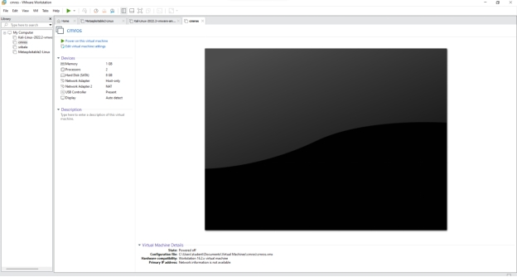

Step4: Power on the cmros virtual machine and consider IP address of cmros

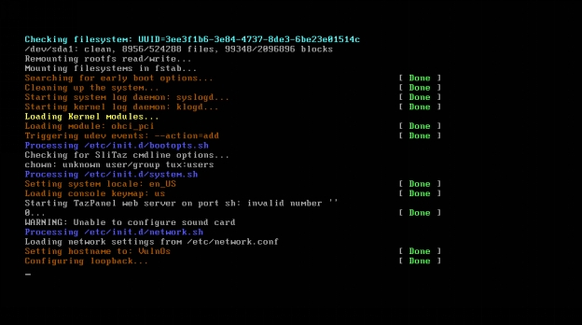

Step5: Open Kali linux on and open terminal

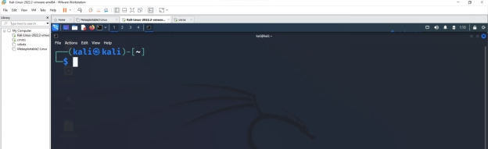

Step6: Start attacking by following commands.

Open nmap tool and give the IP address of the CMROS. It shows only http service only in the nmap tool.

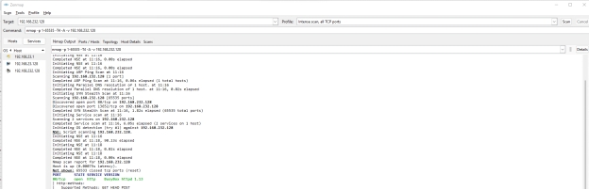

Now use the command below in the kali linux terminal

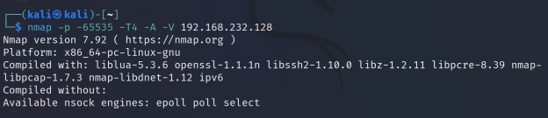

Now open again nmap tool and set intense scan, all tcp ports

→ Now it displays all ports like http and ssh.

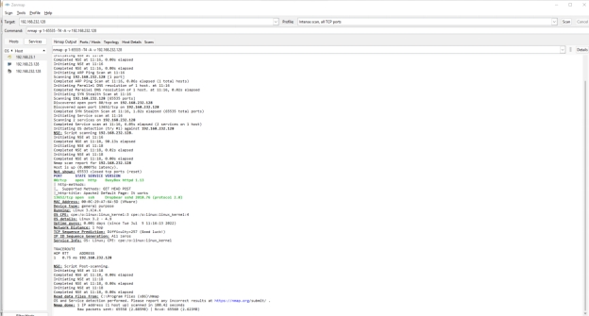

Now open Kali Linux browser and search 192.168.232.128/(cmros ip address)

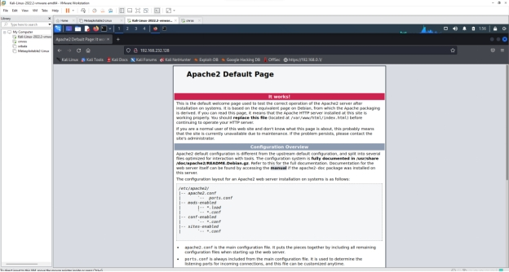

Right click → view page source

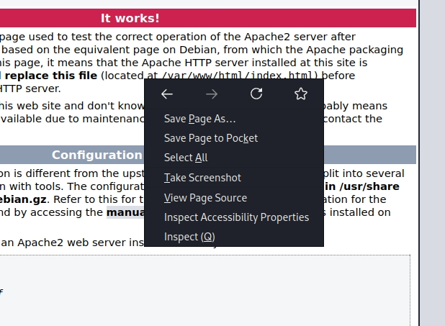

It displays the source code

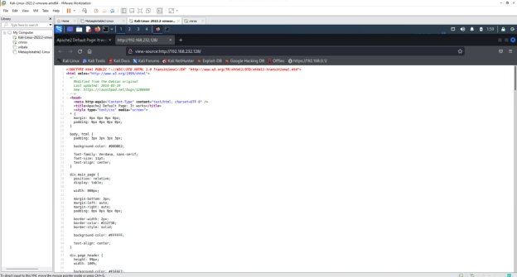

After scrolling down the source code page there we can find username and password

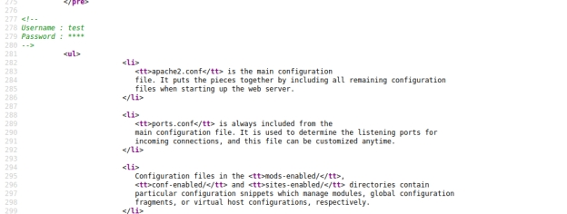

Goto kali linux terminal and use the below command

Use the password we got from the view page source code which is **test**

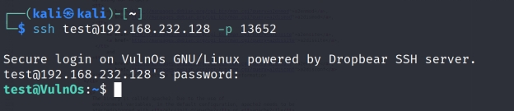

Use ls command

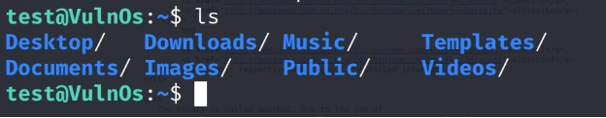

Use whoami to find the user

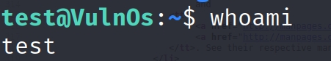

To know the suspicious file redirect to Desktop and the use ls command

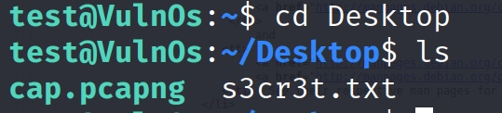

Now go to Windows system, open browser and download WinSCP

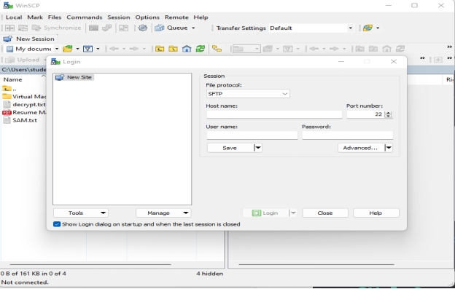

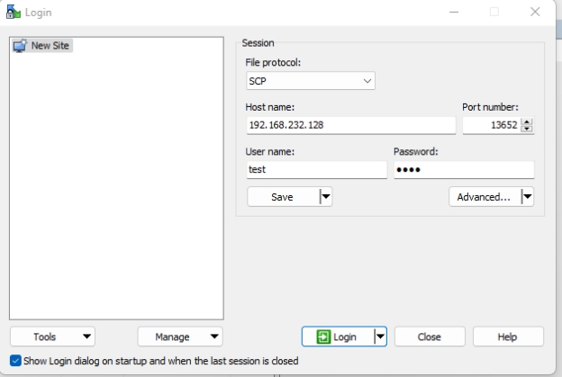

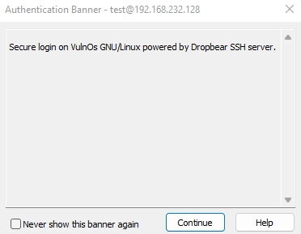

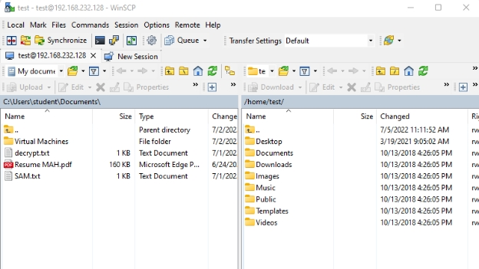

Goto Desktop

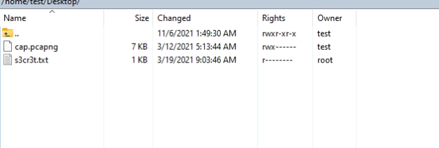

Open kali linux and search for wireshark tool

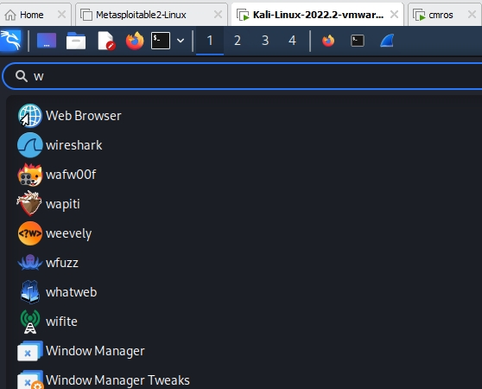

Open wireshark tool in kali

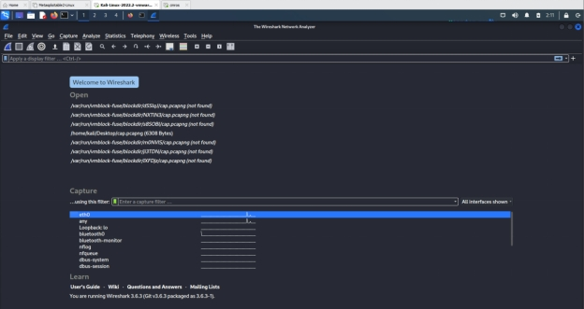

Open cap.pcapng file in the wireshark from desktop folder

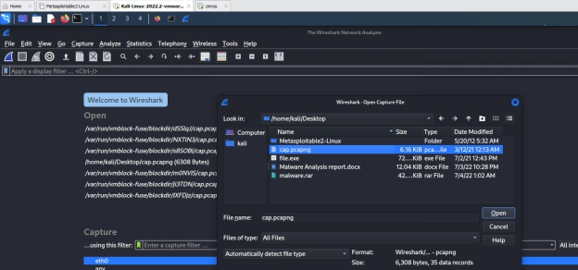

Click any tcp filter and then right click →click follow → TCP Stream

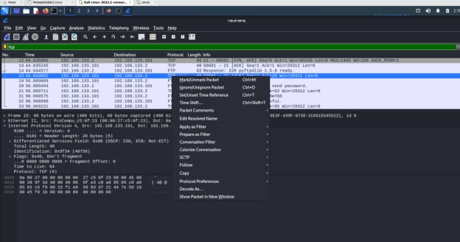

It displays user credentials

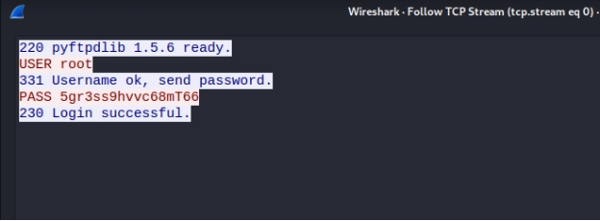

Now copy password and open cmros using above credentials

By using the above credentials we can crack cmros system

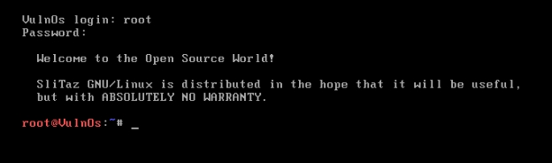

Now use ls command

root@VulnOs:~# ls

Desktop tazinst.conf

root@VulnOs:~# cd Desktop

root@VulnOs:~/Desktop# ls

